Emerging Technologies in the Modern Era
DCIT 26 – Application Development and Emerging Technologies

Bachelor of Science in Computer Science

Submitted by:
Justimbaste Gerome Eujuan B.

Date:
September 9, 2026

Instructor:
Johneros Puyo

Overview of Emerging Technology
When people hear “emerging technology,” they may have different ideas about what technology actually is. Some may think of it as electronic devices, while others may think of machinery that has the potential to shape the world. Throughout history, technologies have been created and continuously developed, greatly shaping how people live, work, and interact with one another.
Digging deeper, what makes it “emerging” is that its future is uncertain. There’s no way to know for sure if a technology will eventually become fully established, disappear over time, or keep getting modified and upgraded as it goes along. As these technologies continue to develop, new possibilities and uses tend to come up along the way.
This leads to the question of what emerging technologies actually are. Simply put, emerging technologies are technologies that are still developing or advancing, but already have the potential to bring major changes to different industries and to society as a whole. A good example of this is Artificial Intelligence (AI). It isn’t a completely new machine, but it keeps evolving and has had a huge impact on many different areas of society.
Emerging Technologies Characteristics
The characteristics of emerging technologies include radical novelty, relatively fast growth, coherence, prominent impact, and uncertainty and ambiguity (Rotolo et al., 2015).
Characteristics | Definition
Radical Novelty | Introducing something new or using existing technology in a new way
Relatively Fast Growth | Developing or spreading at a relatively fast rate
Coherence | Different technologies or research areas becoming connected
Prominent Impact | Having the potential to significantly affect industries and society
Uncertainty & Ambiguity | Future development and effects are not completely predictable

- Radical Novelty
Introduces something new or repurposed technology. An example of this is Artificial Intelligence (AI). AI has been around for many years, proving that there is continuous development in new applications in different fields.
- Relatively Fast Growth
Simply means that it develops quickly in different aspects, mostly in research, products, and services. Because of this rapid development, emerging technologies can continue to improve and become more widely used in different fields.
- Coherence
Different technologies and research areas are connected. They are interconnected and help in developing new applications. For example, AI, cloud computing, and IoT can be used together for different tasks and to create more advanced solutions.
- Prominent Impact
It has the potential to change or transform industries. Its significance greatly affects how people perform different tasks. AI is another good example of this because it can be used in healthcare and education.
- Uncertainty and Ambiguity
Emerging technologies' future uses, effects, and outcomes are full of complete mystery. The future uses, effects, and outcomes of emerging technologies are still a mystery. Life is full of uncertainties, so it is completely unknown whether an emerging technology will eventually come to an end or continue to develop in the future.

Emerging Technology Areas
- Augment Reality (AR) – It adds digital elements (images, text, and sound) to the real world. Users can view digital elements on their gadgets while at the same time view their actual surroundings, creating an immersive view of the real world. Pokémon GO is an example of this, where digital Pokémon appear on the user's screen as if they are in the real world.
- Artificial Intelligence (AI) – Enables machines to perform processes related to human intelligence, such as learning, reasoning, problem-solving, and decision-making. AI can be applied in different fields to help perform tasks that normally require human intelligence. It can be used to help people perform tasks more efficiently and solve problems in different areas.
  - Machine Learning – This AI program teaches a machine to learn from experience. It analyzes data from previous occurrences in order to recognize patterns. After a machine has been trained on a large amount of data, it will be able to make better decisions and improve its response to any given situation. For example, it can be used in healthcare to help identify possible medicines and analyze information more efficiently
- Quantum Computing - Uses quantum mechanics and qubits to solve problems more efficiently than conventional computers. It uses the principles of quantum mechanics to process information in a different way from traditional computers. Quantum computers have the potential to solve certain complex problems more efficiently and can be useful in areas such as scientific research and material development.

The Fourth Industrial Revolution
The Fourth Industrial Revolution (4IR) is currently how we refer to the further development of industrial activities. During the Fourth Industrial Revolution, new intelligent and networked technologies are deployed. The work of human individuals is basically affected by the interactions of machines and systems. It changes the way people work by allowing machines, systems, and data to communicate and work together. Technologies such as AI, IoT, robotics, AR, and VR are some of the main technologies involved in Industry 4.0
Industrial 1.0 | Industry 1.0 was the first stage that occurred in the 18th century. The core of this first phase was mechanical production with the help of water and steam power. This changed the way goods were produced because machines began to assist with tasks that were previously done mainly by hand. It marked an important transition from traditional manual work toward machine-based production.
Industrial 2.0 | Industry 2.0 was the second stage. The power source used in the factories in that era was electricity. Various machines are used in the factories were operated with the help of electricity. Thus, there was a tremendous increase in the production of goods.
Industrial 3.0 | Industry 3.0 was the third industrial revolution, and this revolution brought electronics, computers, and information technology into industries. Automation of industrial processes and reducing the need to use hands and miles of cabling were achieved. The use of computers and automation made production more efficient and allowed machines to perform tasks with greater accuracy.
Industrial 4.0 | The term Industry 4.0 refers to the current industrial revolution and is made up of intelligent, connected, and developed technologies such as AI, IoT, Robotics, Augmented Reality(AR), and Virtual Reality(VR). Such technologies allow for communication between machines and systems as well as humans.

Building Blocks of Industry 4.0
- Big Data Analytics - Big Data Analytics is the process of collecting, organizing, and analyzing huge amounts of data or even many different data sources, in order to extract the relevant and valuable information from it and to generate new knowledge. Industry 4.0 uses Big Data Analytics for analyzing data from different sources.
- Internet of Things (IoT) - The Internet of Things (IoT) refers to physical objects, goods or things which are provided with sensors, data collectors or other devices for connection to the internet. They can exchange data with other objects and/or with other devices via the internet and thus can interact with each other. In Industry 4.0, IoT allows machines and systems to communicate with each other, helping industries monitor processes and respond to changes in real time.
- Cloud Computing - Cloud Computing is a technology that delivers software, scaling, and data resources over the internet as a service. The customer does not need to store all data and applications on a local computer or local networks. In Industry 4.0, cloud computing can be used to store and process data from machines and devices, making it easier to manage information and support data-driven services.
- Augmented Reality (AR) - Augmented Reality can be used in Industry 4.0 to help workers in their daily tasks by providing them with information in the real world in digital form. Workers in a warehouse can use AR to identify parts. Workers who repair machines can use AR on their mobile devices to get step-by-step instructions for repairing the machines.

Conclusion and Recommendation
In conclusion, emerging technologies are continuously developing and have the potential to bring significant changes to different industries and society. They are not always completely new, since existing technologies can also develop new applications and purposes. Their characteristics show how they grow, connect with other technologies, create impacts, and have uncertain future outcomes. Other technologies which are part of Industry 4.0 and part of the networked and intelligent systems in the industry are AI, AR Machine Learning and Quantum Computing. As a Technology Analyst, I advise companies and authorities to keep an eye on these technologies and to check out their potential, the potential risks and their practical application. Knowing these technologies can help organizations make informed decisions about technology adoption, improve their operations, and prepare for future developments.

References
- Artificial Intelligence (n.d.). In TechTarget. Retrieved from https://searchenterpriseai.techtarget.com/definition/AI-Artificial-Intelligence
- Cann, O. (2018). These are the top 10 emerging technologies of 2018 [Web logpost]. Retrieved from https://www.weforum.org/agenda/2018/09/top-10-emerging-
technologies-of-2018/
- Cloud Computing (n.d.). In Techtarget. Retrieved from https://searchcloudcomputing.techtarget.com/definition/cloud-computing
- Internet of Things (IoT) (n.d.). In Techopedia. Retrieved from https://www.techopedia.com/definition/28247/internet-of-things-iot
- Rotolo, D., Hicks, D., & Martin, B. (2015). What is an emerging technology?. SPRU Working Paper Series, 44, 1-34. doi: 10.6084/M9.FIGSHARE.1335986

Proof for AI Checker and Grammarly results
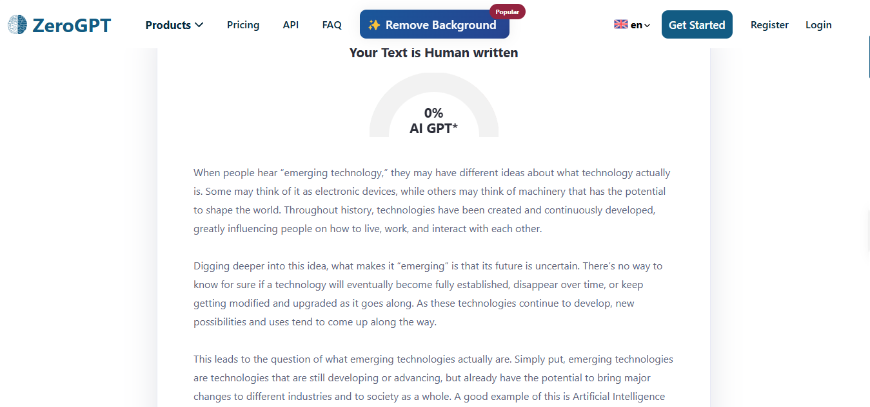
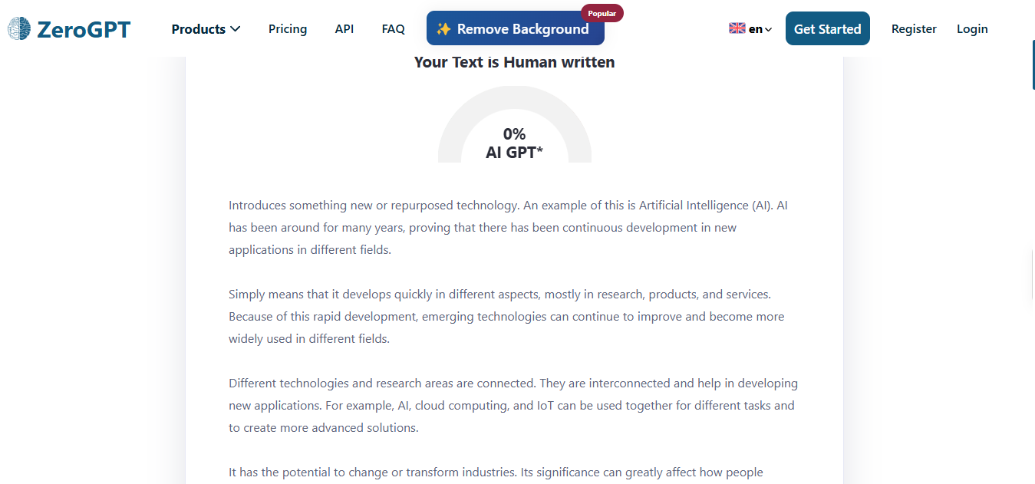
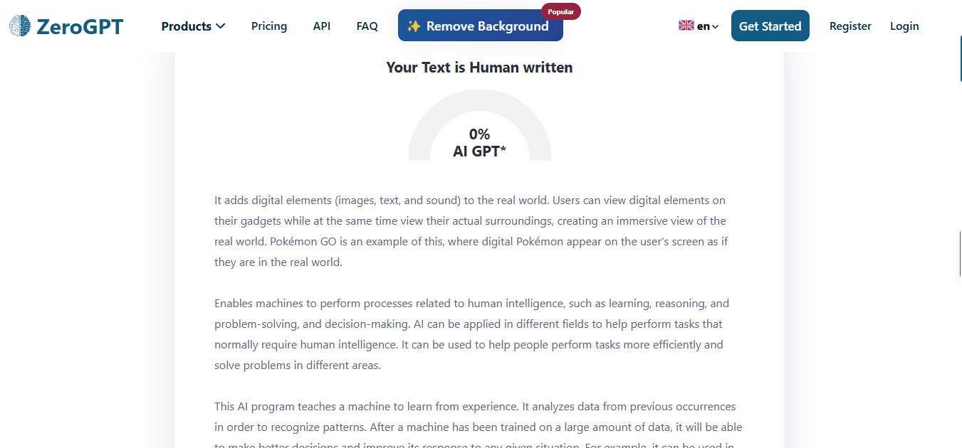
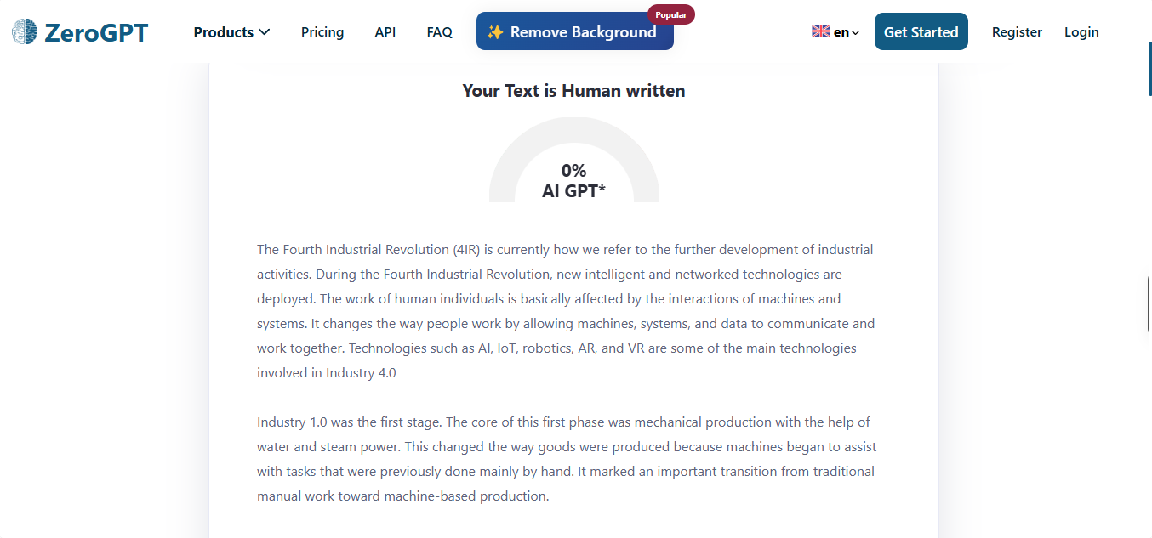
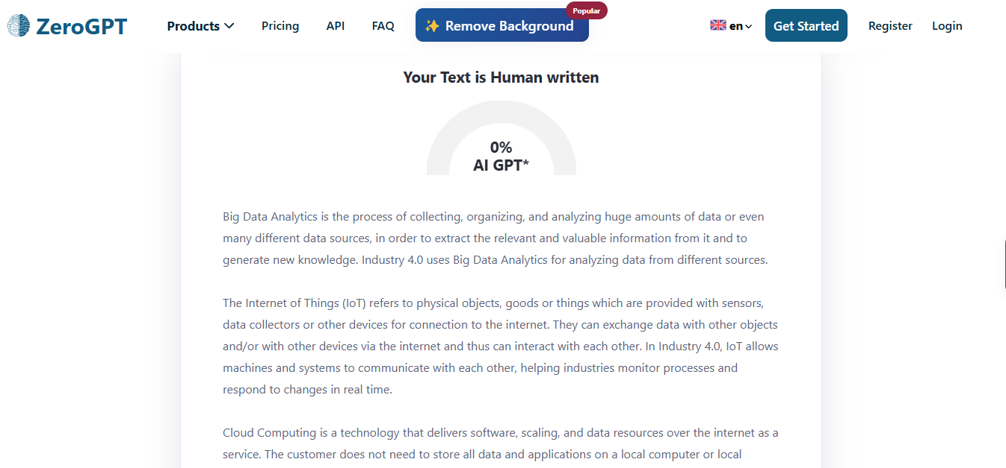
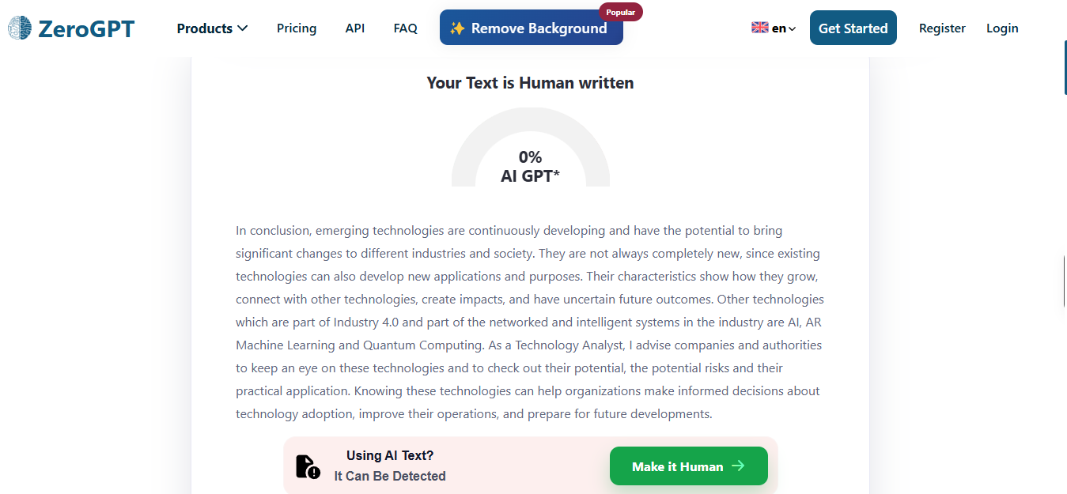
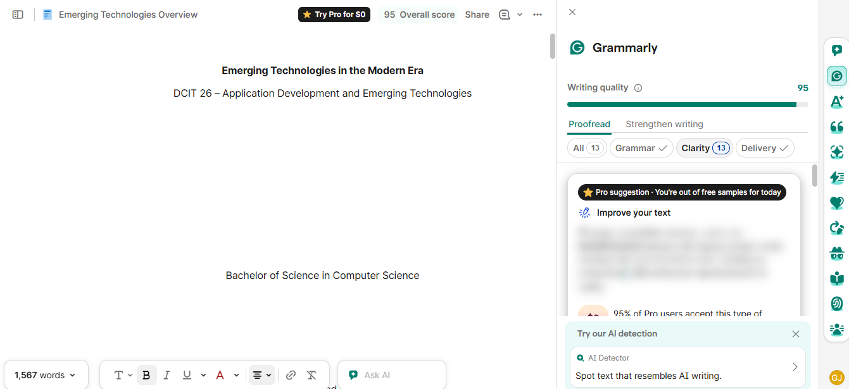

Criteria
Rubric:
Criteria | Weight
Accuracy of content (based on lecture)
Completeness of all sections
Depth of analysis and explanations
Use of examples and applications
Organization
Originality (own words no copying)
Total: 100%

